ICAR-CENTRAL INLAND FISHERIES RESEARCH INSTITUTE
(INDIAN COUNCIL OF AGRICULTURAL RESEARCH)
BARRACKPORE: KOLKATA - 700 120
Phone No. (033) 2592 1190/1191
E-mail: cifri@vsnl.com, Website: cifri.res.in

F. No. Swachh Bharat/Adm.II/ | Dated 27th March, 2018

Action taken report on Swachh Bharat Abhiyan for the month of March, 2018:-

Activity at ICAR-CIFRI, Bangalore:-
As a part of Swachh Bharat Abhiyan, cleaning activities were conducted in Research Centre, ICAR-CIFRI, Bangalore on 24th March, 2018. All scientists and staff of the centre actively participated in the cleaning process. Store rooms were cleaned store and prepared the list of old files which are to be disposed off and Equipments for repairing and condemnation were segregated for listing for further approval.
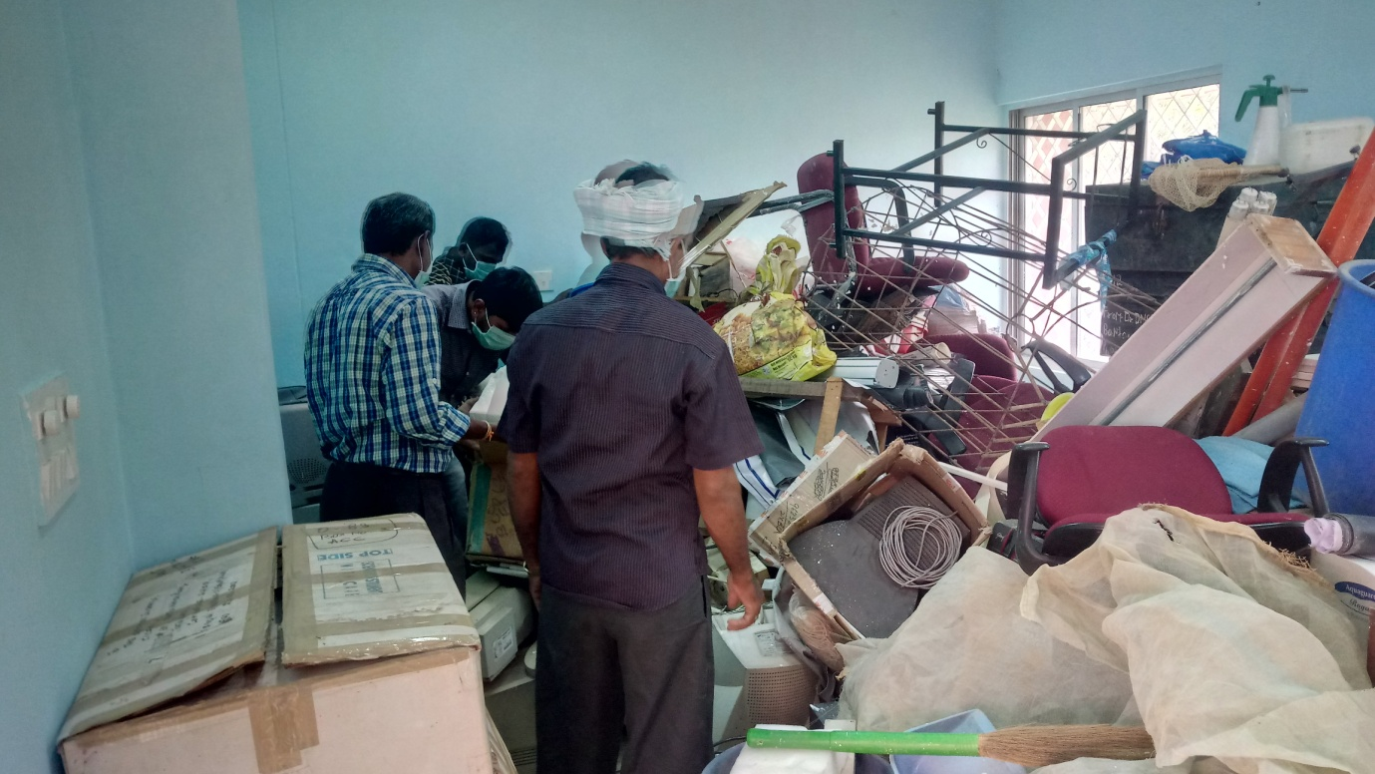
Photo 1: Store room cleaning
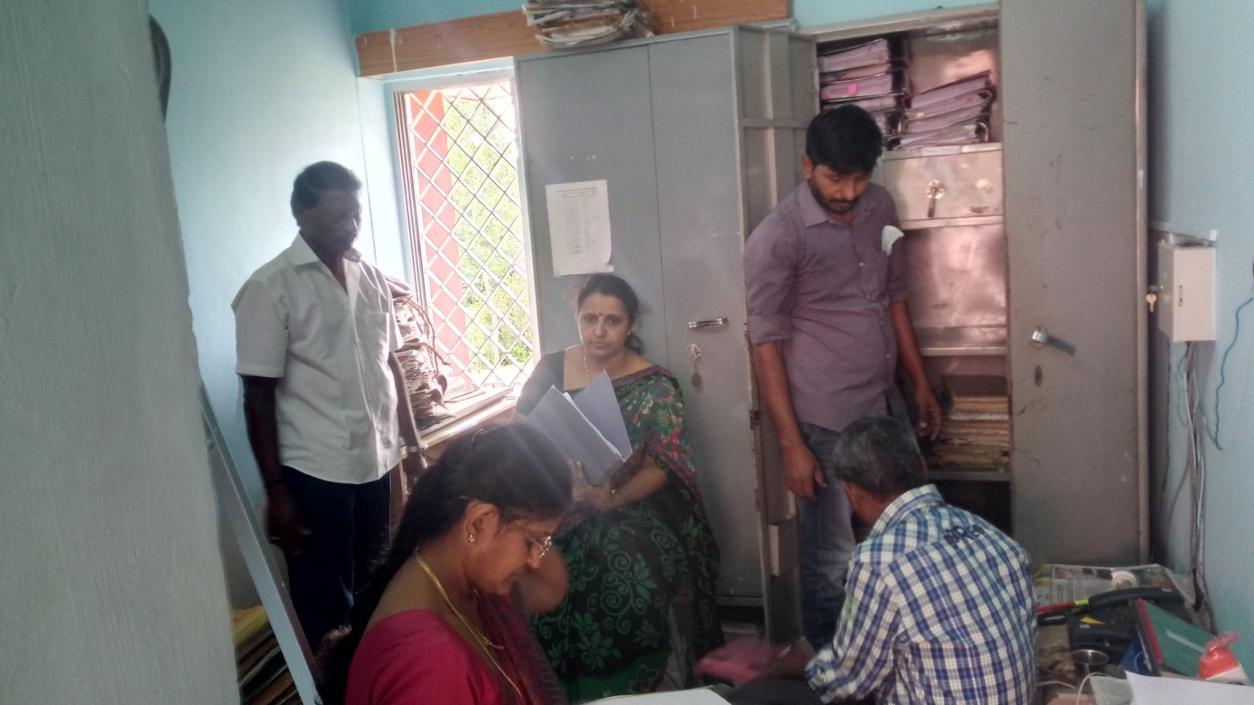
Photo 2: Store room cleaning

Activity at ICAR-CIFRI, Kochi:-
Activity on Swachh Bharat Abhiyan for the month of March, 2018 was carried out at this centre on 19.03.2018 by the Officers and Staff of the centre. The centre’s library was cleaned, enumerated and reorganized for better utilization.
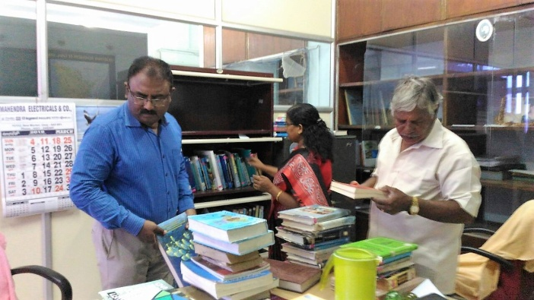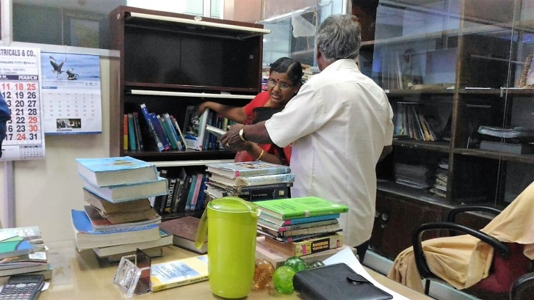
Photos above:- The Staff members of ICAR-CIFRI, Kochi are cleaning Office premises.

Activity at ICAR-CIFRI, Vadodara:-
The Staff members of the centre took part in Cleanliness drive of the laboratory rooms, office rooms and premises. The Seating arrangement of Scientists were also reorganized.

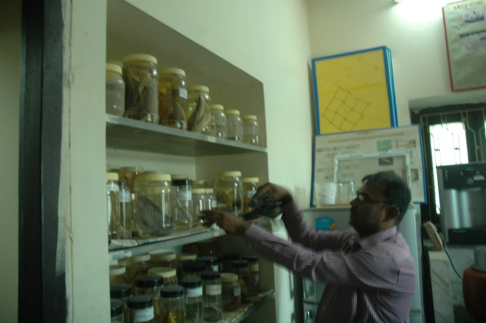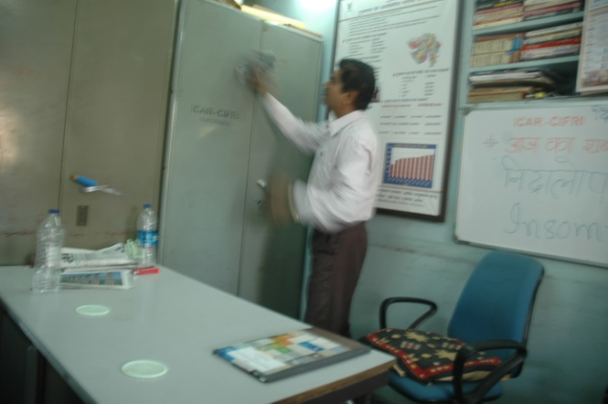
Photos above:- Cleaning of Chemistry Laboratory and Office Room.

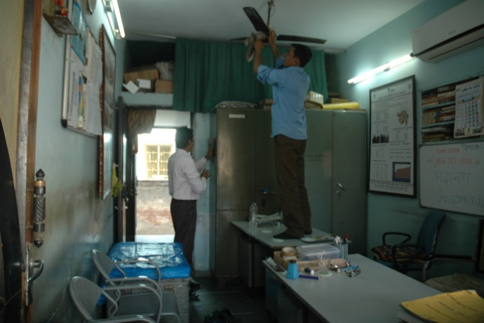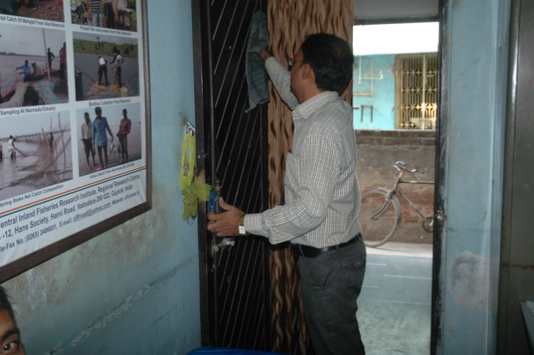
Photos above:- Cleaning of Office Room and Technical Room.

Activity at ICAR-CIFRI, Kolkata:-
At CIFRI Kolkata Centre, CGO Complex, Salt Lake Kolkata, all the regular and contractual staff have routinely engaged a part of their duty hours for keeping the working ambience clean. The scientists of the Centre has spent more than a week at Barrackpore HQ for attending different meetings like RAC, IRC, Platinum Jubillee functions etc. during March 2018. But still we have maintained our office premises as well as the instruments/equipment clean and tidy throughout the period to keep up with the ideology of “Swachh Bharat”. Some of photographs are provided below.

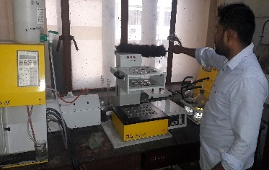 | 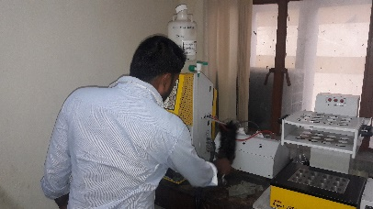
Photos above:- Cleaning of Laboratories.
-----------------x-----------------

